***Chapter 4.***

# System Analysis

**4.0SystemAnalysis**

System Analysis is a Process of collecting data , understand the process involved, identifying problem and recommending feasible suggestion for improving the system functioning.

**4.1Studyof Current System**

We have to build such application which can acts internet free service it means that you have authorization of to open our site and you can see our new launch product, and detail about Electronics, Foods& Fashions etc. which we launch in market.

**4.4Feasibility Study**

➢The Feasibility analysis is categorized under four different types.

1) Operational Feasibility.

2) Technical Feasibility.

3) Schedule Feasibility.

4) Economical Feasibility.

**(1)Operational Feasibility:-**

Basically Operational Feasibility as how application work as execute in market

There are type of people which is focus user of application in arm research. We set focus on smooth operative of are application because some user for technical person with sufficient knowledge of how to operate application and some of done people who not really technical sound so our UI is user friendly and feasible to all.

**2) Technical Feasibility:-**

In process of Application we mention all the process and structure in particular co-or dinar between development, design, and test.

We set example in real market and we found are application is fairways and good to work on it.

**3) Scheduling Feasibility :-**

Here we are create schedule for our application and our team or project partner follow mention time line to execute follow application and we have also move for work before actual project deadline or submission date.

**4) Economical Feasibility :-**

There is so many criteria of application success but main bound ray of application is cost and time feasibility so Estimation of time& cost feasibility is fruitful to are clients in our

company. We doing this project is IDP so well structured even byour company.

**4.5Requirement Validation**

• Functional requirement defines internal working of application .The calculations, data manipulation and processor specific functionality for customers.

• “Validation typically involves actual testing and takes alter verifications are complemented”

• Validation refers to the processofusingthesystemintheactualliveenvironmentin order tofind error .If the Result so brained from the System are proper, the systemic valid; elseit is no.

• A sour project is to built dynamic web-site, there are no criteria such as windows authentication but still some security must be provided in essence of making the rights of certain entity to be limited to them. Certain valid action criteria that are need listed

below.

**4.6Functionof System**

**4.6.1 Use Cases, event trace or scenario**

Use case diagram shows the typical in the action of user to system. Below figure Shows the how user interact with system.

He inserts or delete or update or view there cords from the system. If he /she want to enter in the system he has to pass from login portion of system for checking of authorization of person.

•**Functional Use Case Diagram.**

**Various notations used in the use case diagrams are:**

➢**Use Case**

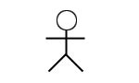

➢**Actors**

➢**Association Relationship**



**Use case Diagram:**

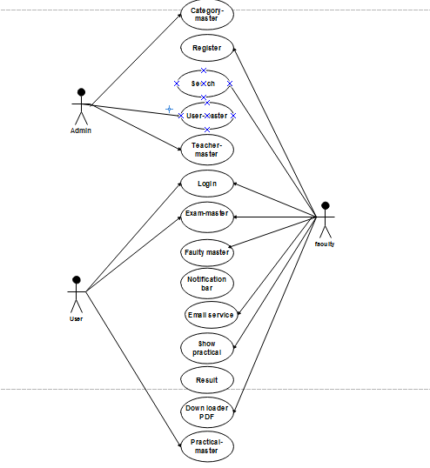

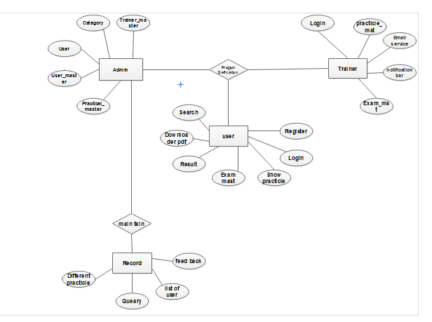**4.7.DataModeling**:

**4.7.1E-R diagrams:-**

**4.7.2 System Activity Diagram**

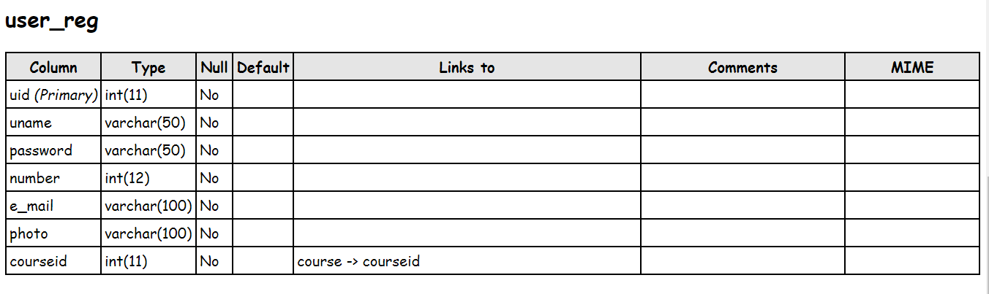**4.7.2 Data Dictionary**

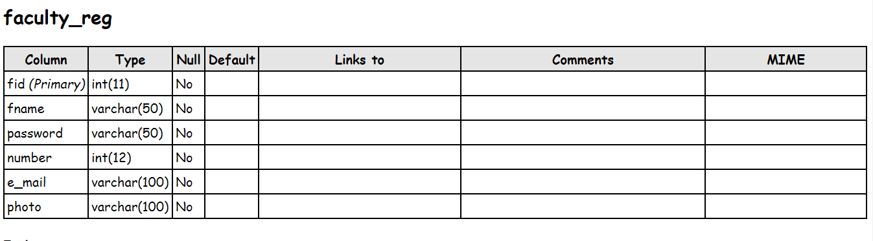

**4.8Functional&BehavioralModeling**

**4.8.1 Context Diagram**

Data Flow Diagram is a graphical aid for defining systems inputs, outputs and processes. It represents flow of data through the system.

The DFD use modern methods of System Analysis. They are simple to the extent that the types of symbol sand rules are very few. DFDs serve two purposes:

(1) Provide a graphic tool, which can be used by the analysts to explain his under standing of the system to the user

(2)They can be readily converted into a structured chart which can be used in

**4.8.2 Data Flow Diagram(Context Level)**

Data Flow Diagram is a graphical aid for defining systems inputs, outputs and processes .It represents flow of data through the system.

The DFD sure used in modern methods of System Analysis. They are simple to the extent that the types of symbols and rule sare very few. DFDs serve two purposes:

(1)Provide a graphic tool, which can be used by the analysts to explain his understanding of the system to the user

(2) They can be readily converted into a structured chart which can be used in design.

**DFD:-**

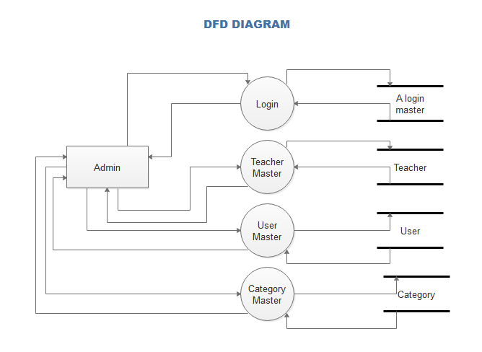

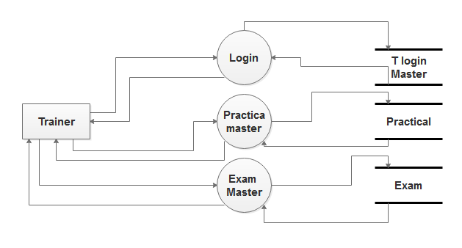

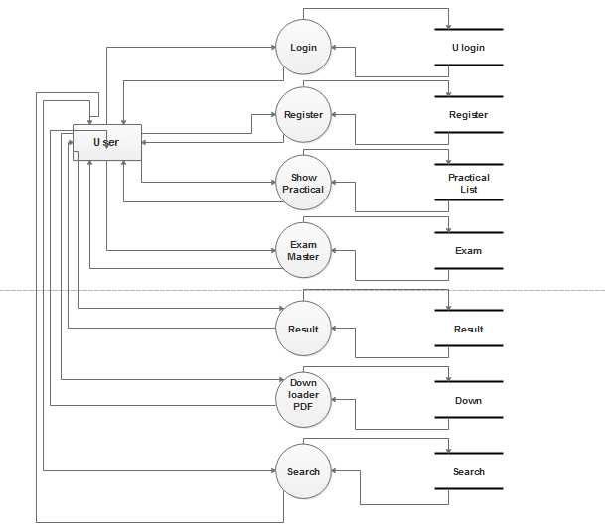

➢**Data Flow Diagram(Notation)**

Process that transforms data flow.

SourceorDestination ofdata

Data Flow

Data Store

**4.9Main modules of new system:-**

**1) Administrator:** Admin Panel from where the users can be Activated , Deactivated , and Deleted .The new faculty can be added from the Admin Panel and also the existing faculty details can be updated or deleted from there itself. The admin can also add new course or update or delete the existing course.

**2) User (Client):**User is the registered users of this system. The user can use the editor and

Perform the practical and the will have to submit to the specific Trainer. The Trainer will check the practical and give marks to the user.